BOOKENDS HOSPITALITY PVT. LTD.
Internal Operations — Regulatory Readiness Series

FSSAI Schedule 4 & FDCA Compliance Readiness Report

CAPICHE — UNI, Ahmedabad, Gujarat

Outlet / Brand | Capiche
Location | Univercity, Ahmedabad, Gujarat
Business Category (presumed) | Restaurant
Report Type | Internal walk through dated 15 August 2026.
Inspection/Audit By | Vishal Patel
Report Prepared By | Vishal Patel

Ref | Priority | What the evidence shows
K19 ★ | Critical | A pest (cockroach) was photographed on the floor on the audit day, despite this checkpoint being scored 2. The pest-control certificate on file is addressed to a different business name and had already lapsed for over a  year.
K15 ★ | 1 evidence | Fitness certificates not available.

Ref | Checkpoint | Rating | Priority | Remark
S1 ★ | FSSAI licence displayed and valid; Food Safety Display Board put up | 4 | Compliant
Ref | Checkpoint | Rating | Priority | Remark
S2 | FSSAI licence number printed on menu | Non-Compliant | High | 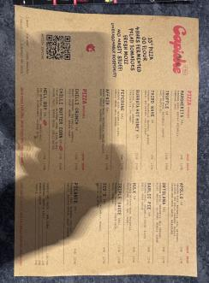  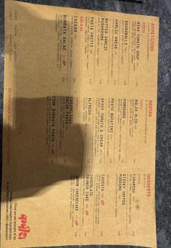

Ref | Checkpoint | Rating | Priority | Remark
S8 | Hand wash or sanitizer available for guests and staff | 2 | Compliant | —
S10 | Drinking water potable/filtered; dispenser and jug clean | 1 | Partial | 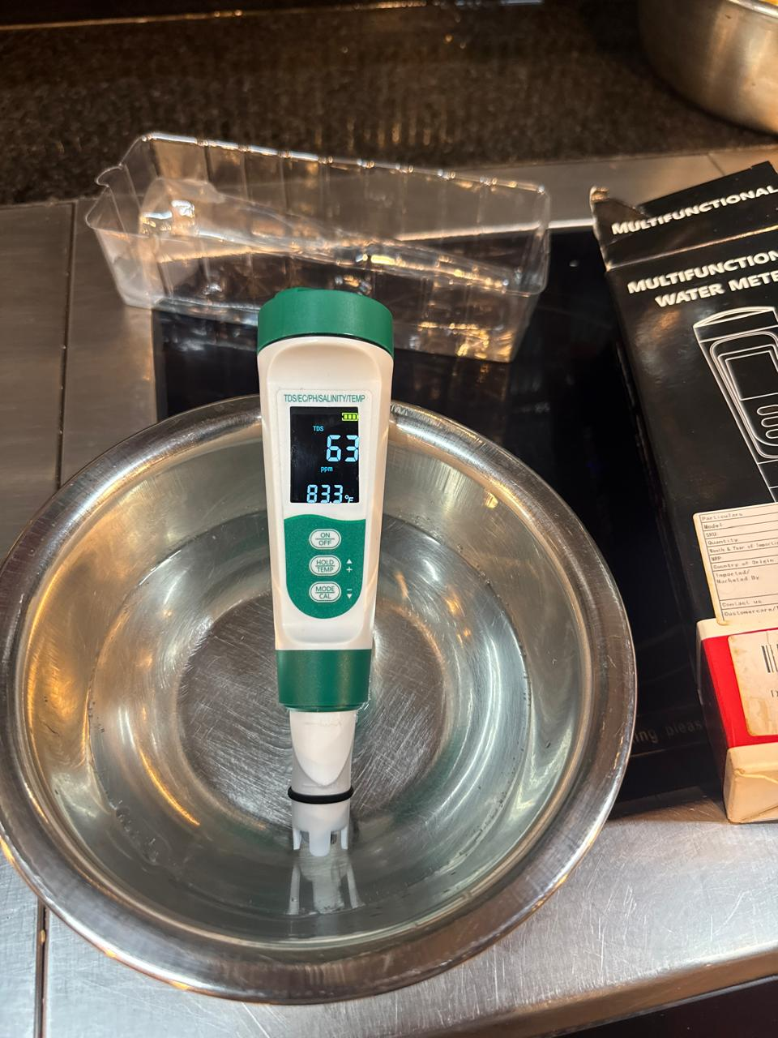
S13 | Restrooms clean and stocked; doors do not open directly into food area | 2 | Compliant | —
K18 | Hand wash stations stocked — soap, sanitizer, paper towel | 2 | Compliant | —
K20 | Drain traps in place, flowing and clean; no standing water | 2 | Compliant

Ref | Checkpoint | Rating | Priority | Remark
S11 | Table condiments/sachets within expiry date; containers clean | 2 | Compliant
K1 ★ | No expired or undated items anywhere on the premises | 0 | Major | 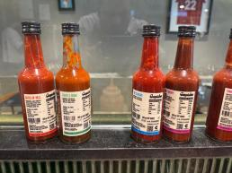  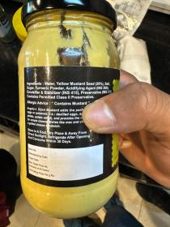  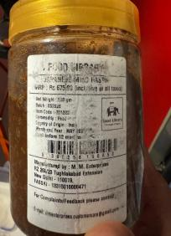  No Date
Ref | Checkpoint | Rating | Priority | Remark
K2 | Decanted containers labelled with name and date; FIFO followed | 1 | Partial | 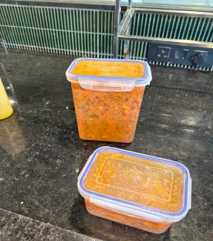  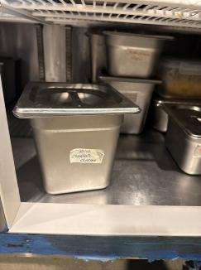
K22 | Exhaust and hoods degreased; ventilation adequate; lights protected | 2 | Compliant | —

Ref | Checkpoint | Rating | Priority | Remark
K4 ★ | Raw and cooked food completely segregated | 4 | Compliant | —
K5 ★ | Veg segregated in storage and prep | 4 | Compliant | —
K6 ★ | Chiller ≤ 5°C, freezer − 18°C; temperature log up to date | 4 | Compliant | —
K7 | Hot holding ≥ 60°C; cooking to a core temperature ≥ 75°C | 2 | Compliant | —
K8 | Thawing only under refrigeration — never at room temperature | 2 | Compliant | —
K12 | Frying oil within TPC limit; oil-change log up to date | 2 | Compliant
K14 | Only approved colours/additives used; declaration on file | 2 | Compliant

S3 | Tables, chairs and other guest-area surfaces clean and sanitized | 2 | Compliant
S12 | Waste bin covered, foot-operated, not overflowing | 2 | Compliant
S14 | Pest barrier functional at entrance (air curtain / insect-o-cutor); no signs of pests in dining area | 0 | Major | No record
K9 | Chemicals labelled not mention and stored away from food | 1 | Partial | 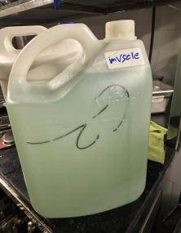
K19  ★ | No pest activity; pest-control service record up to date; stations mapped | 0 | Major | No record
K21 | Waste segregated, bins covered, emptied daily | 0 | Major | 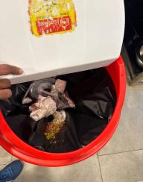

S6 | Service staff in clean uniform  — cap, trimmed nails, no jewellery | 0 | Major | 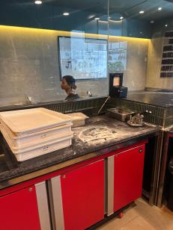
S7 | No unwell staff on duty; cuts/wounds covered with waterproof dressing | 2 | Compliant
K15 ★ | Medical fitness certificate up to date for every food handler | 0 | Major | Not available
Ref | Checkpoint | Rating | Priority | Remark
K17 | Kitchen staff — cap, apron, trimmed nails, no jewellery; no smoking or paan | 0 | Major | 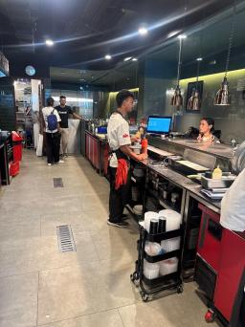
K3 | Storage 15 cm off the floor; no cartons or food on the floor. | 2 | Compliant | —
K10 | Dry store clean, ventilated, pest-free. | 2 | Compliant | —
K11 | Colour-coded boards / separate prep tools in use | 2 | Compliant | —
K13 | Food-contact surfaces and equipment clean — no rust, damage or wooden patches | 1 | Partial | 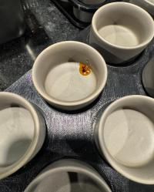

Ref | Checkpoint | Rating | Priority | Remark
S15 | Veg mark and allergen information on menu, where applicable | 0 | Major
Ref | Checkpoint | Rating | Priority | Remark
K16 | FoSTaC-certified supervisor on roster; certificate available | 0 | Major | Not available
Ref | Checkpoint | Rating | Priority | Remark
K23 ★ | Water potability report valid  — tested within the last 6 months | 0 | Major | Team reports an informal daily check is done, but there is no documented report; the formal 6-monthly lab report has not been renewed. & TDS-63.
K24 | Deep-cleaning schedule up to date and followed; dispense log with temperature (CK checklist) | 2 | Compliant
S4 | Floors, walls, ceiling clean — no cobwebs, seepage or flaking paint | 2 | Compliant | —
S5 | Counters and display units clean; displayed food covered and temperature-held. | 2 | Compliant | —
S9 | Crockery, cutlery and glassware clean, chip-free, stored covered. | 2 | Compliant | —

Score & Grade
Section | Available marks | Obtained marks | %
A — Service Area | 32 | 23 | 71.9%
B — Kitchen Area | 62 | 37 | 59.7%
Total (Overall) | 94 | 60 | 63.8%

Conclusion
- Overall standing — 60/94 (63.8%), Needs Improvement; all 39 checkpoints were scored. 4 of the 8 ★ criticals are Non-Compliant (K1, K15, K19, K23), but S1 passes — the licence is displayed and valid — and K4, K5 and K6 hold, so segregation and the chiller and freezer controls are sound.
- The kitchen is the weaker half — 37/62 (59.7%) against the service area's 23/32 (71.9%). Front of house now largely holds: floors and walls, crockery and the waste bin all pass, and drinking water has moved up to Partial. The kitchen's losses are expired or undated stock (K1 ★), staff grooming (K17), waste segregation (K21) and the documentation set.
- Five items from Satisfactory — the three documentation items (K15, K16, K23) carry 10 marks and the pest pair (S14, K19) another 6; closing those five alone reaches 76/94 (80.9%), inside the Satisfactory band, with no other change required.

